1. Always write conclusions/observations in simple English language after each analysis (like below fig shows observations obtained after analysing pair plot for iris)

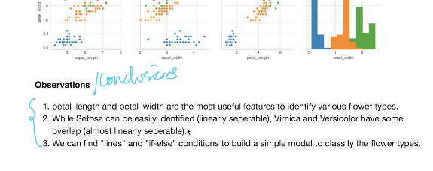

1. Never deviate from your objective, that means always do analysis that are relevant your problem to find.
2. Univariate Analysis can be done using
   1. PDF
   2. CDF
   3. Box-plots
   4. Violin plots

Bivariate analysis can be done using

1. Pairplots
2. Scatter plots

